Newly Elected Supreme Master
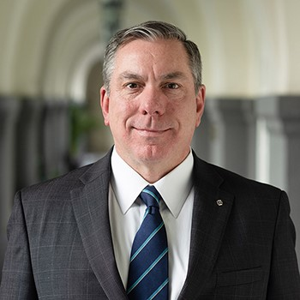
Michael McCusker of Memphis, Tennessee, was elected to lead the Fourth Degree of the Knights of Columbus as Supreme Master; he will also continue as a member of the Board of Directors, following his election to that position last August. McCusker, a decorated military veteran and a Fourth Degree Knight since 2004, succeeds Dennis Stoddard, who retired March 1 after 13 years as Supreme Master. In recognition of Stoddard’s distinguished record of accomplishments, the Board of Directors voted to accord him the honorary title of Supreme Master Emeritus.
A member of the Knights of Columbus since 1988, Michael McCusker served as State Deputy of Tennessee from 2019 to 2021 and was elected to the Board of Directors in August 2022.
McCusker has worked as a criminal prosecutor for more than 20 years and currently is assistant district attorney general for the 30th Judicial District of Tennessee. He also served in the U.S. Army Reserves, and then the Tennessee National Guard, for more than two decades, including a deployment to Afghanistan from 2005 to 2006. McCusker was awarded a Bronze Star for his service in Afghanistan, as well as an Army Commendation Medal for his actions during a search-and-rescue mission there in 2005. McCusker is a graduate of the University of Tennessee and earned his law degree from the University of Memphis. He is a member of St. Michael the Archangel Council 17578 and Deacon Lee R. Hurst Assembly 2183, both in Memphis. He and his wife, Theresa, live in Germantown, Tennessee, and have three children.

